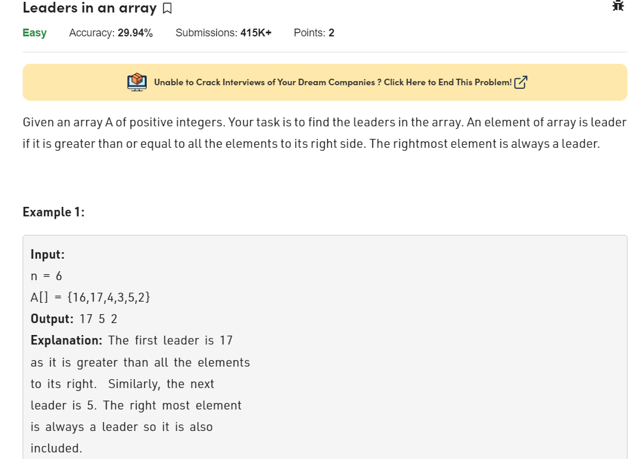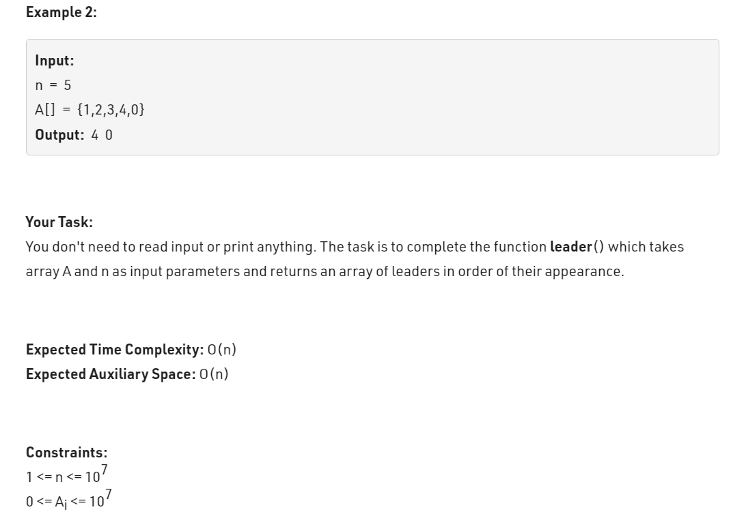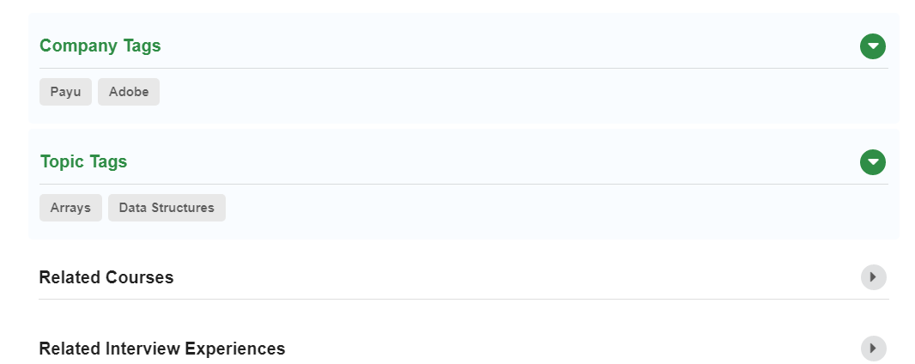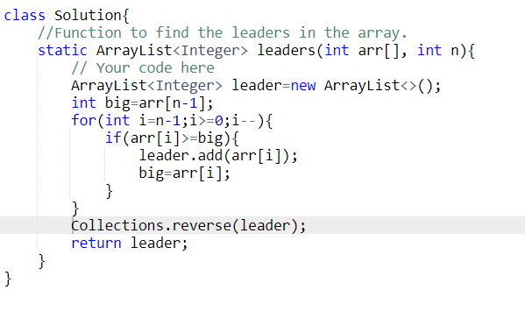

class Solution{

//Function to find the leaders in the array.

static ArrayList<Integer> leaders(int arr[], int n){

// Your code here

ArrayList<Integer> leader=new ArrayList<>();

int big=arr[n-1];

for(int i=n-1;i>=0;i--){

if(arr[i]>=big){

leader.add(arr[i]);

big=arr[i];

}

}

Collections.reverse(leader);

return leader;

}

}